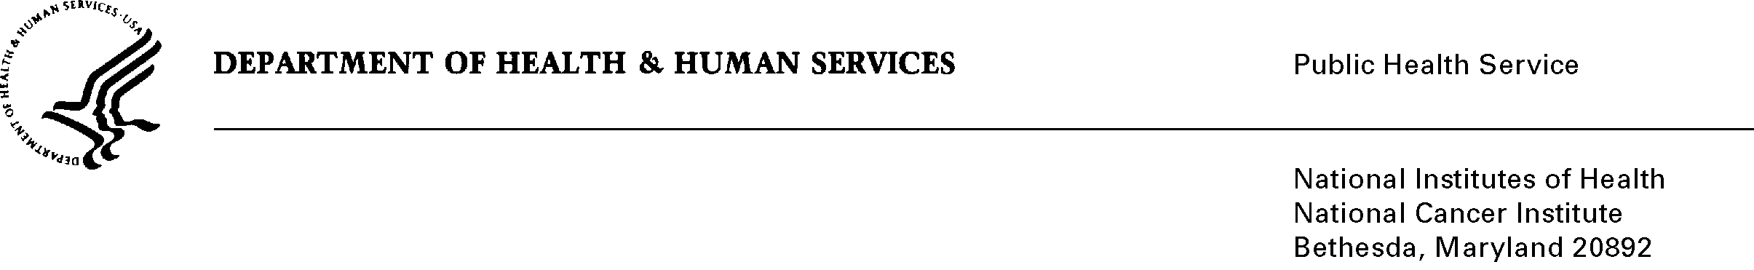
MEMORANDUM

DATE: March 27, 2020

TO: Principal Investigators and Operations Staff of DCP-Supported Phase 0-2 Cancer Prevention Clinical Trials Program (“Consortia”) and CP-CTNet

FROM: Eva Szabo, MD, Director, CP-CTNet, DCP, NCI

SUBJECT: Additional Guidance Regarding Reporting of Minor Deviations for Clinical Trials Supported by the NCI DCP Phase 0-2 Cancer Prevention Clinical Trials Program

Interim Guidance was provided to Principal Investigators and Operations Staff on March 13, 2020 that addressed the accrual and care of participants on open cancer prevention clinical trials supported by the Phase 0-2 Cancer Prevention Clinical Trials Program (Consortia) during the COVID-19 pandemic. An email communication from Margaret House sent on March 18, 2020 addressed the monitoring of Consortia studies during the pandemic.

This memorandum provides additional guidance to address alternative procedures for the reporting of minor deviations resulting from changes to study related activities that are necessitated by efforts to maintain the safety of enrolled participants during the COVID-19 pandemic. This guidance does not apply to minor deviations that occurred prior to the pandemic.

If a participant at a site is unable to complete a required study related activity per the CIRB approved protocol or if a study visit needs to be delayed, this is a protocol deviation and should be evaluated for Serious and/or Continuing Noncompliance (SNCN).

If, in the opinion of the Principal Investigator (PI), the missed visit or intervention or deviation from established study related activities poses a risk to the safety of the subject or jeopardizes the scientific integrity of the study (the ability to draw conclusions from the study data), this event should be reported to the DCP Medical Monitor and the CIRB by the site investigator per standard process.

If, in the PI’s determination, neither the safety of the subject nor the scientific validity of the trial is impacted by the deviation from study related activities, this will be considered a minor deviation and the following alternative process for deviation reporting may be used. Instead of reporting these minor deviations to the Medical Monitor as per standard process, these minor deviations would need to be documented in the medical record by the Responsible Investigator with the reason for the deviation (e.g., mandatory or precautionary travel restrictions to prevent exposure to the virus) and brief justification for why the deviation was considered to be minor (e.g., routine follow-up on patient no longer on active therapy). These minor protocol deviations only need to be reported to the organization leading the trial (i.e., Contract Lead Organization or CLO) so that the CLO can report them to the NCI CIRB at the time of continuing review for the trial. A study-specific log of these minor deviations shall be maintained by each site’s staff to facilitate study monitoring and CIRB reporting.

Examples of alternative procedures that could be considered minor protocol deviations are listed below (this list is not all-inclusive).
- Substitution of telephone contact or videoconferencing technology (i.e., “virtual” or “telemedicine” visits), including adverse event assessments, for in-person visits if the Responsible Investigator determines that the phone/virtual visit is adequate to achieve the central purpose of the visit and assure the safety of the participant.
- Delay of study visits if in the judgment of the Responsible Investigator the benefit of delay/omission of a visit outweighs the risks of exposure of the patient to the virus by coming in for an in-person visit (or travel is not feasible), and an alternative method (phone or virtual visit) is not possible .
- Use of outside laboratories for safety lab checks, if arrangements can be made for such services.
- Delays in or omissions of protocol-required specimen collections or surveys that do not impact overall study integrity
- Changes to specimen shipment schedules (e.g., batching of specimens vs. real-time submission to central laboratory)
Site Staff should contact the appropriate Medical Monitor or Nurse Consultant with questions if there is uncertainty or disagreement about the severity of specific deviations.

All study visits, laboratory tests, imaging, treatment schedules as specified in the protocol should resume as soon as emergency public health control measures for COVID-19 are no longer needed in the participant’s location to confirm patient safety. It is understood that significant delays of protocol-required study visits, laboratory tests, imaging, treatment delays, and inability to obtain mandatory tissue essential to achieve the study endpoint would result in discontinuation of the subject’s participation in the clinical trial if appropriate safety monitoring can no longer be maintained or the study integrity is compromised.

DCP will continue to closely monitor the conduct of the trials being conducted in the Consortia program and, if the current challenging situation continues longer than expected, in the CP-CTNet program, to see if there are additional accommodations that can be made to help maintain continuity of care of participants in clinical trials. Principal Investigators and Site Staff should contact the appropriate Medical and Scientific Monitors for their respective trials with any issues that may arise during this outbreak of COVID-19.

