Setting Up Your Computer for A Board Meeting
Table of Contents
Using Zoom for a Board Meeting 1
Viewing the Agenda in IRBManager 3
Managing Multiple Windows During the Board Meeting 6
Splitting Your Screen 6

Using Zoom for a Board Meeting

CIRB meetings use Zoom as the meeting interface. A staff member at Emmes will control the Zoom window, allowing all users to see the same screen.
The Zoom meeting will appear as a camera icon (red arrow) on your computer’s primary task ribbon, usually located at the bottom of the screen.

Zoom defaults to a Full Screen view and displays both the presentation window as well as the attendee’s field. The Zoom window is divided into three primary sections:
- The Attendee ribbon (red arrow) displays the name, photo (if any), or video (if activated) of each attendee.
- The Presentation window (yellow arrow), which displays the presenter’s screen (if Share Screen if activated).
- The Zoom Tool ribbon (orange arrow), which provides additional attendee meeting control selections including the Mute, Stop/Allow Video, Chat, and Share Screen features.
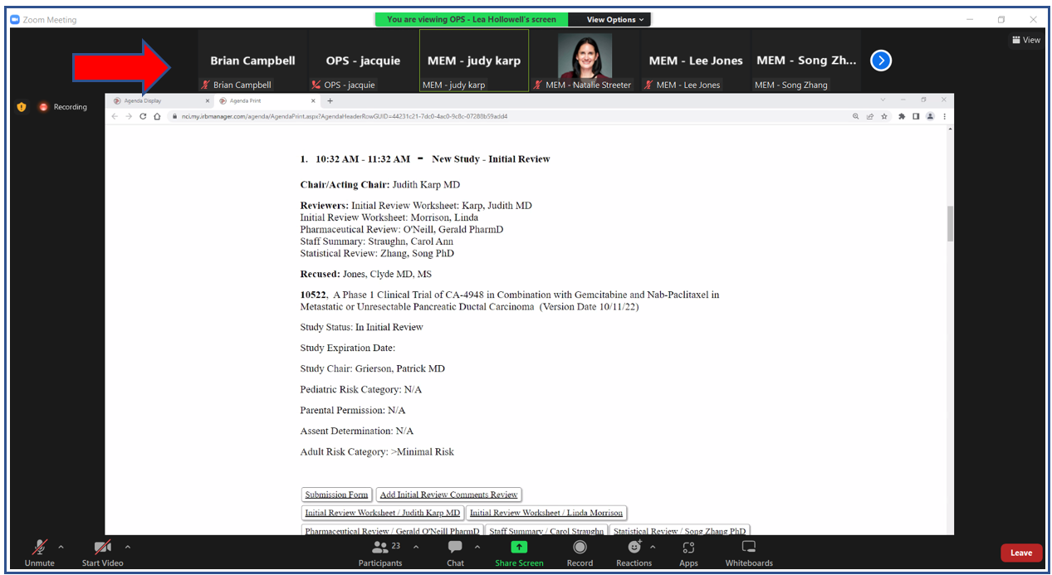
A green highlight will appear around the box of the attendee currently speaking. 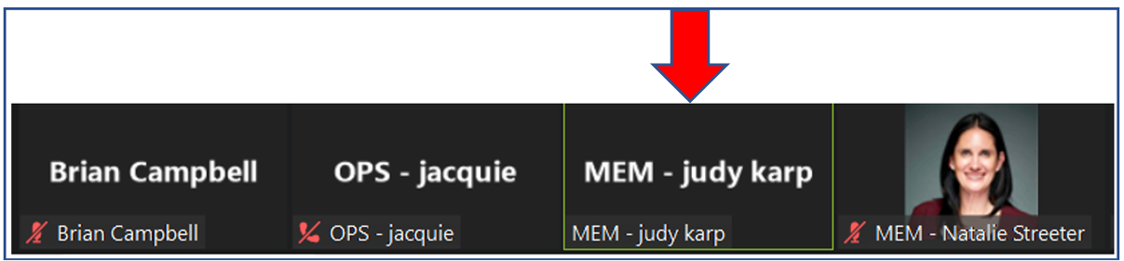
You have the option to tailor the size of the Zoom window.
- You may adjust the display within the Zoom meeting window occupies. To view only the presentation and exclude the attendee information, click the View link in the upper right of the Zoom window (red arrow).

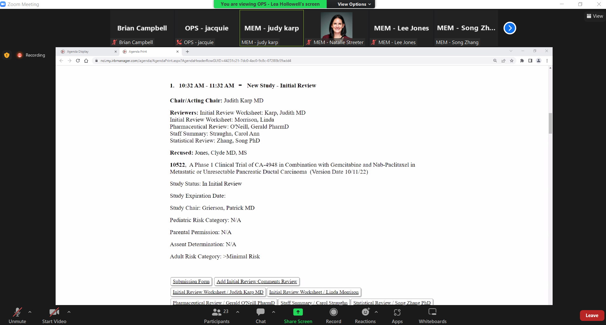
- This will expand the View link to display additional items. Click on Fullscreen (red arrow).
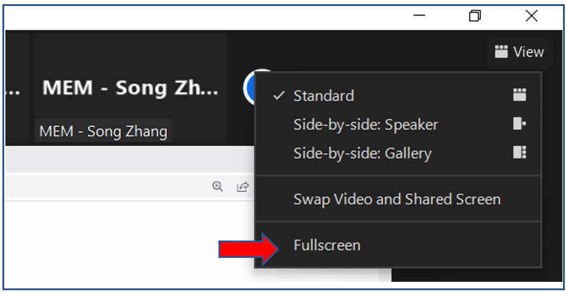
- This will restrict the view to the presentation only. You can click the ESC button to return to the default view of Zoom.
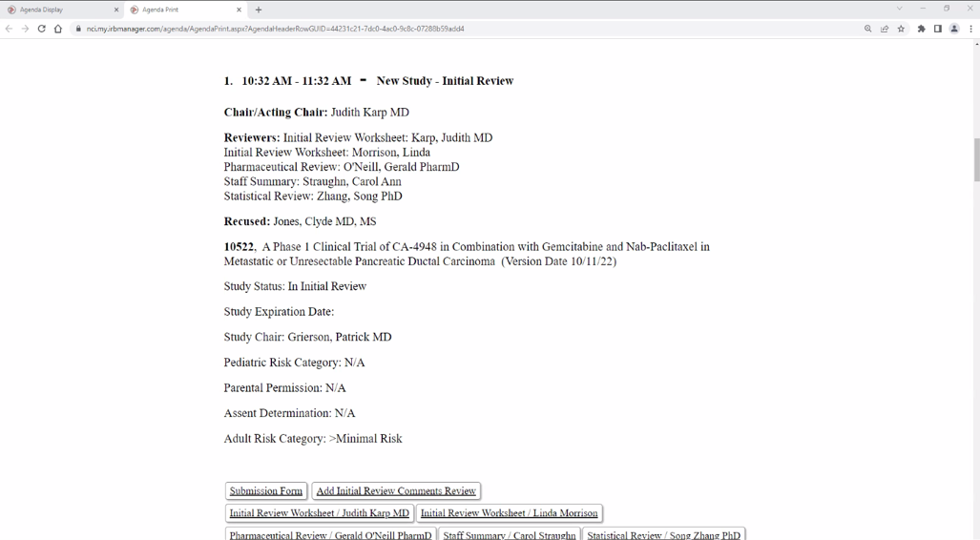
- You may also change the default view to change how the Attendee ribbon is displayed.
  - The Side-by-Side view (Speaker) option will move the Attendee to the right side of the screen and display only the current speaker.
  - The Side-by-Side view (Gallery) option will move the Attendee to the right side of the screen and display all attendees.

Viewing the Agenda in IRBManager
- Log into IRBManager (https://nci.my.irbmanager.com/).
- From the Home page, click on the Board tab (blue arrow) to view the meeting Agenda you wish to see. This will display all current, uncompleted meetings.

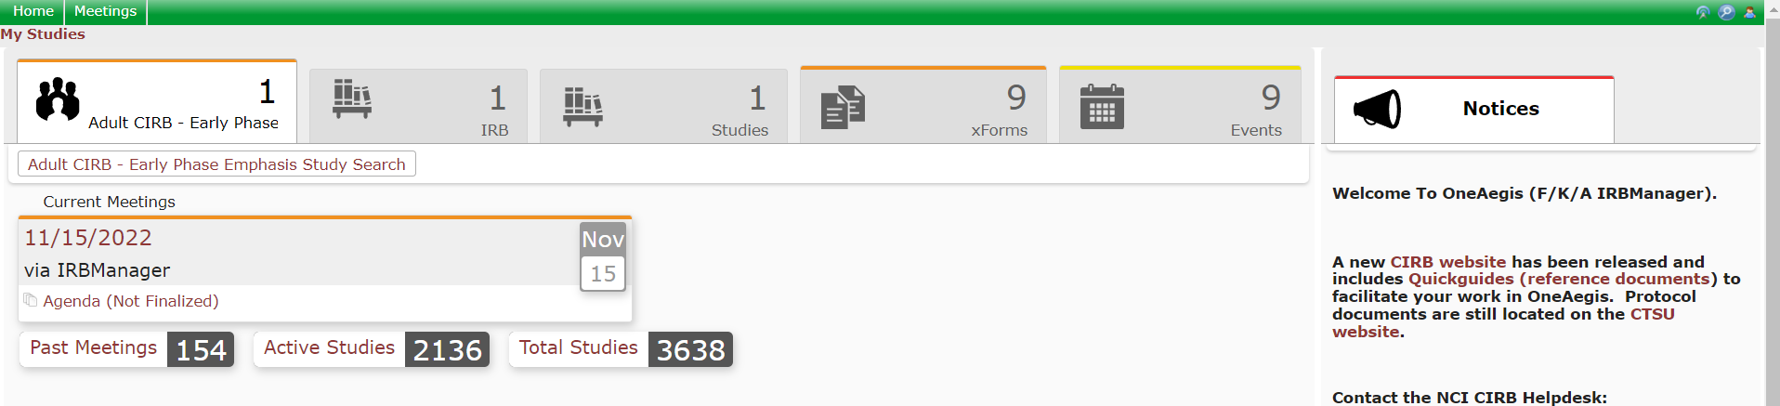

- Click on the “Agenda (Not Finalized)” (red arrow). This will open the agenda in a new tab in your browser.

- Scroll down to the section you wish to review. Active links will appear as an underlined blue text (red arrow).

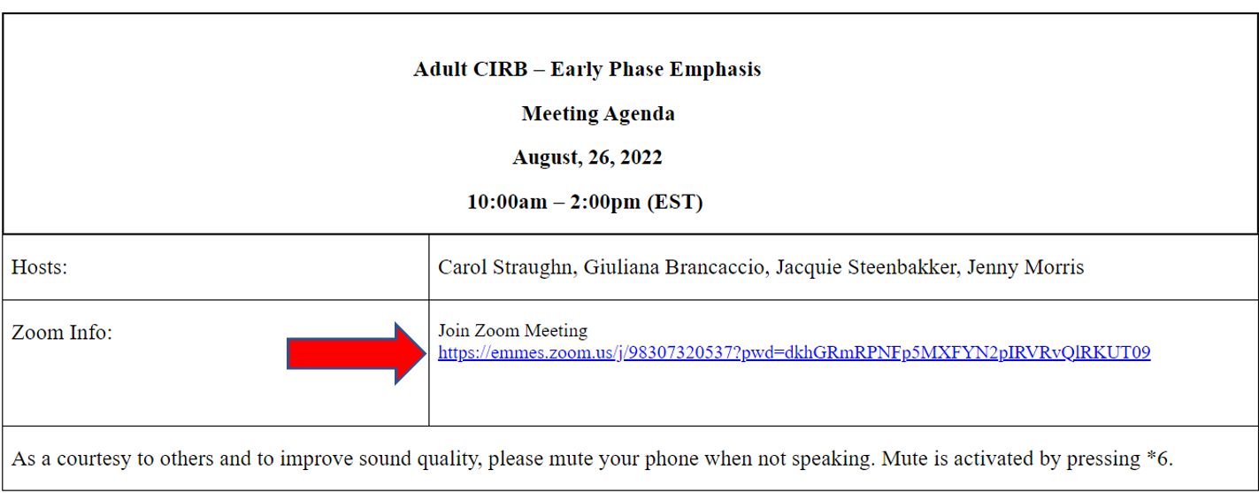
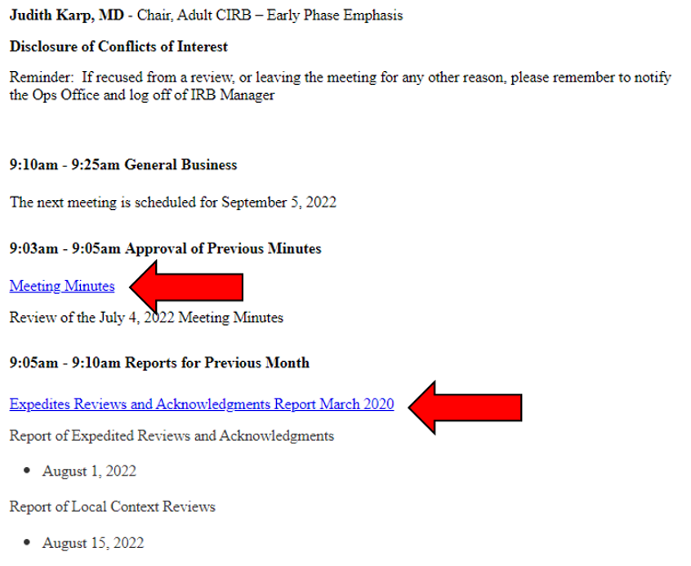

Viewing an Existing Reviewer Worksheet
- Review assignments can be found under each Full Board event.

- Assigned reviewers are listed at the top of the event (red arrow).

- Assigned Reviewer Worksheets are listed at the bottom of each event (blue arrow) and include the type of Reviewer Worksheet followed by the name of the assigned Board member. You can view any Reviewer Worksheet that has been started by clicking on the appropriate box. NOTE: Reviewer Worksheets that have not been started or don’t have saved changes will not appear and the interface will display only the Worksheet header information.
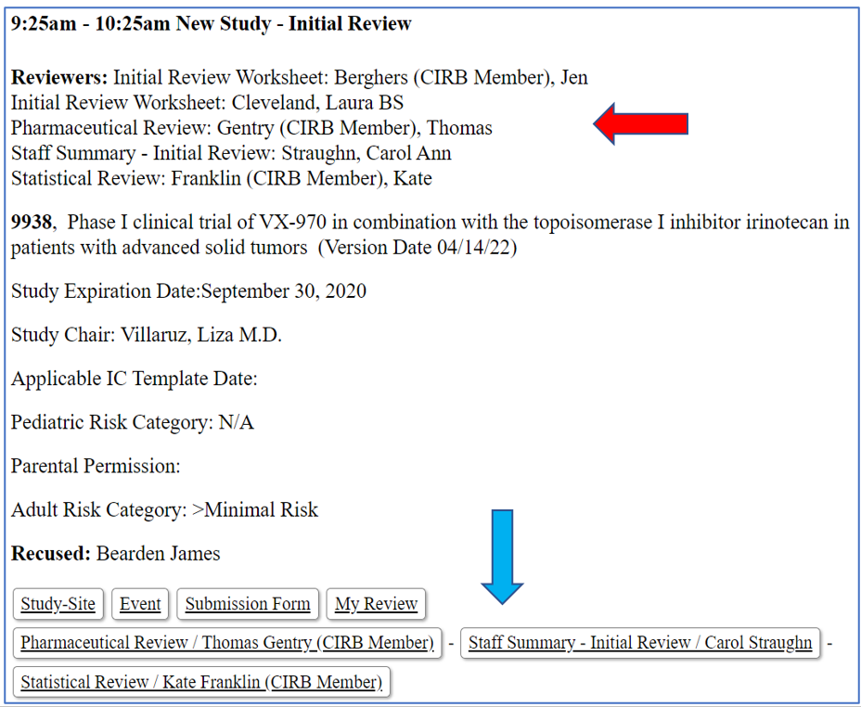

Managing Multiple Windows During the Board Meeting

Attendees have the option to view other applications, like the Agenda in IRBManager, during the Board Meeting, in addition to the Zoom meeting window.
Attendees can use the Toolbar ribbon, usually located at the bottom of the screen, to move between the Zoom meeting window (red arrow) and Chrome, for example, which may have IRBManager and the Meeting Agenda available as open tabs. Clicking either icon will display that application, in full screen, for the attendee’s use.
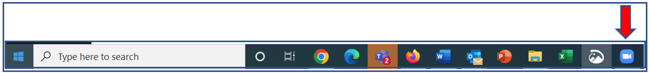

Splitting Your Screen

Users have the option to split the computer screen to view the Zoom Meeting Presentation window alongside another window (e.g., Chrome displaying IRBManager).
To split your screen, you will need to configure each window independently.
Click on the Zoom Meeting Presentation window. Place your cursor in the top of the window, and then, while holding the Left mouse button, drag the mouse to the right side of the screen. This should automatically reduce the size of the window. You can now scale the window to the appropriate size by moving your cursor to the edge of the application window, and once the double arrow appears, adjust that side of the window accordingly. Usually adjusting left side and the bottom is sufficient.
Repeat this process for the other window(s) you wish to configure.
Clicking on the Restore Down icon (red arrow) will restore the window to full screen. Clicking the icon in full screen mode will convert it back to the configured half screen as well.
