Instructions for Board Members for Navigating the User Dashboard in IRBManager

Table of Contents

Accessing IRBManager 2
Users with only IAM accounts 2
Users with ID.me accounts linked to their IAM accounts 3
Configuring User Dashboard 4
Viewing a Meeting Agenda 9
Viewing an Existing Reviewer Worksheet 11
Viewing the Application for a Study Review 12
Starting an Assigned Reviewer Worksheet for a Study Review 15
Using the Email Notification 15
Reviews Tab on User Dashboard 15
Review Assignment on the Agenda 15
Starting an Unassigned Reviewer Worksheet for a Study Review 19
Navigating the Application 22
Viewing Archived Agendas 24
Viewing CIRB Resource Page 25

Accessing IRBManager

Users with only IAM accounts
- Go to https://nci.my.irbmanager.com/
- Click the Identity and Access Management box (red arrow)
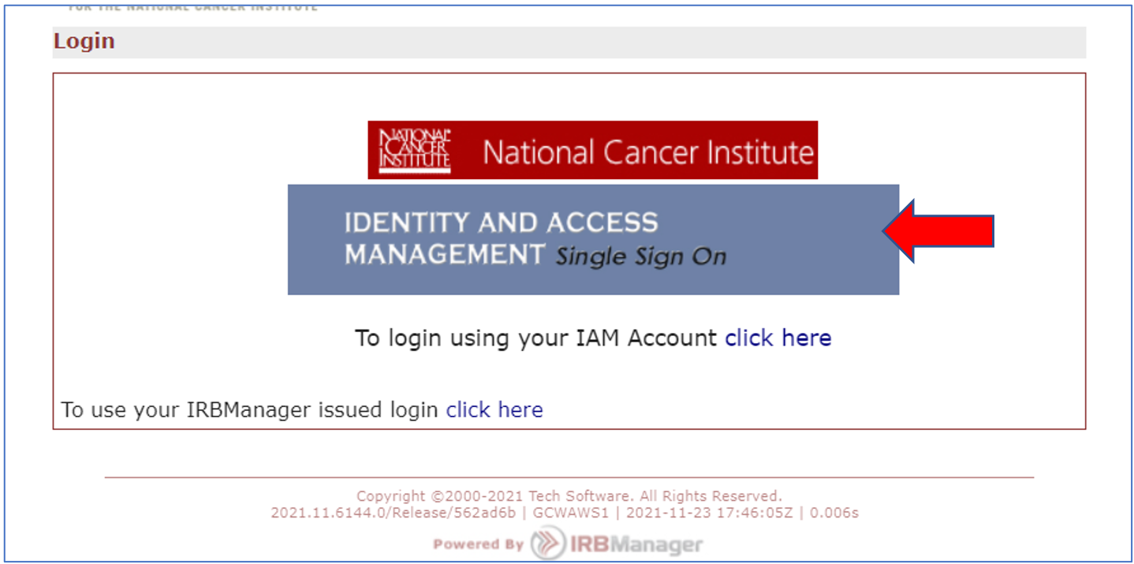
- In the Username and Password fields, enter your IAM username and password (red arrow), and then click the Sign In button (yellow button).
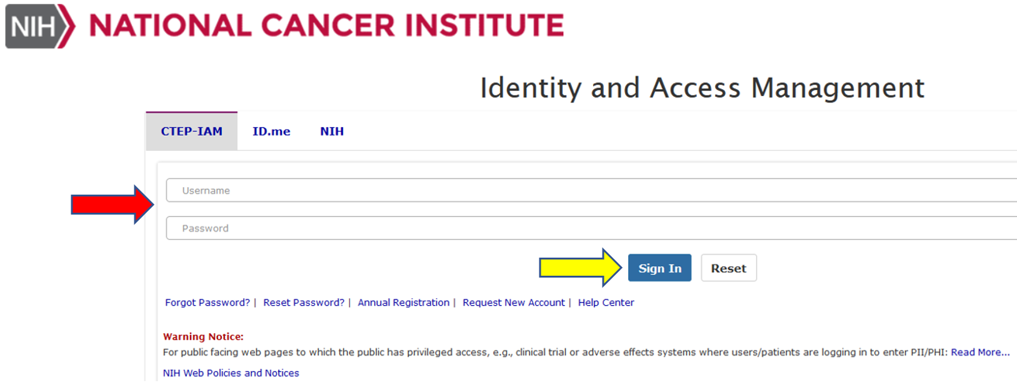

Users with ID.me accounts linked to their IAM accounts

An instructional guide for existing IAM account holders is available for your reference.

- Go to https://nci.my.irbmanager.com/
- Click on the ID.me tab (blue arrow).
- Then click on the Sign in with ID.me button (red arrow).

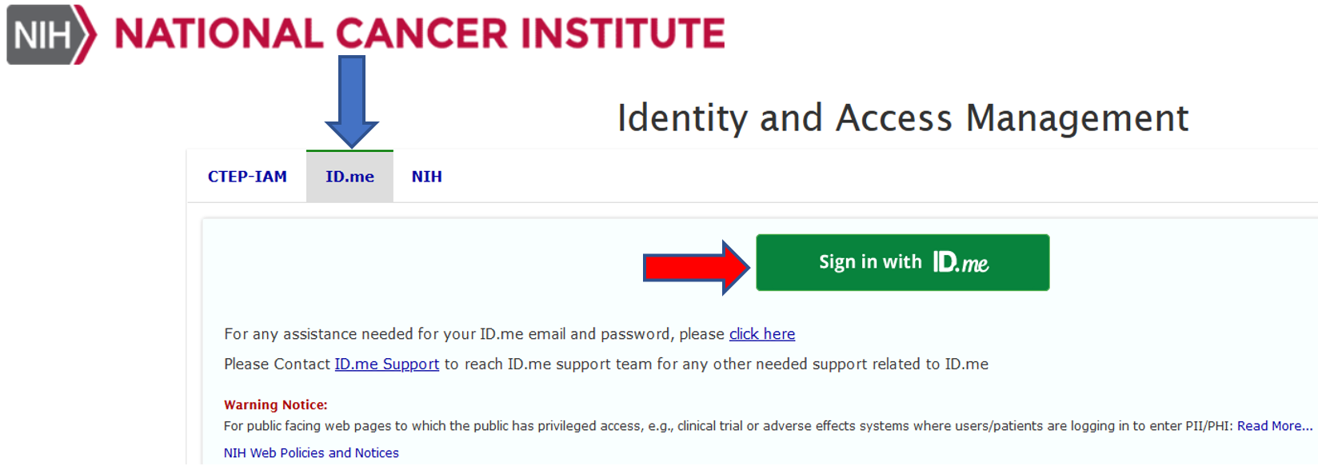

- Enter your ID.me email and password into the appropriate fields (red arrow).
- Click the Sign in button (yellow arrow).

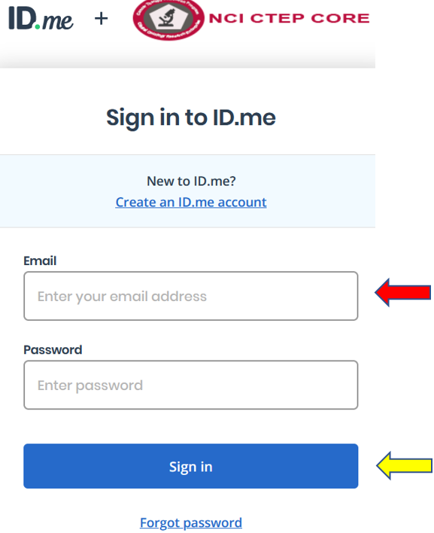

Configuring User Dashboard

- Before beginning, please configure your browser(s) to allow pop-ups for IRBManager. This functionality is crucial for IRBManager to perform correctly. In a new tab, enter “How to enable pop-ups for <browser name>” and follow the instructions.

- There are two views of the user dashboard in IRBManager – Power Dashboard and Bubble Dashboard. The Bubble Dashboard provides a more graphic interface that provides easier navigation. This will be the default view for all Board members moving forward. To change to the Bubble Dashboard, click on the “Use Bubble Dashboard” (red arrow) under the left navigation tree.

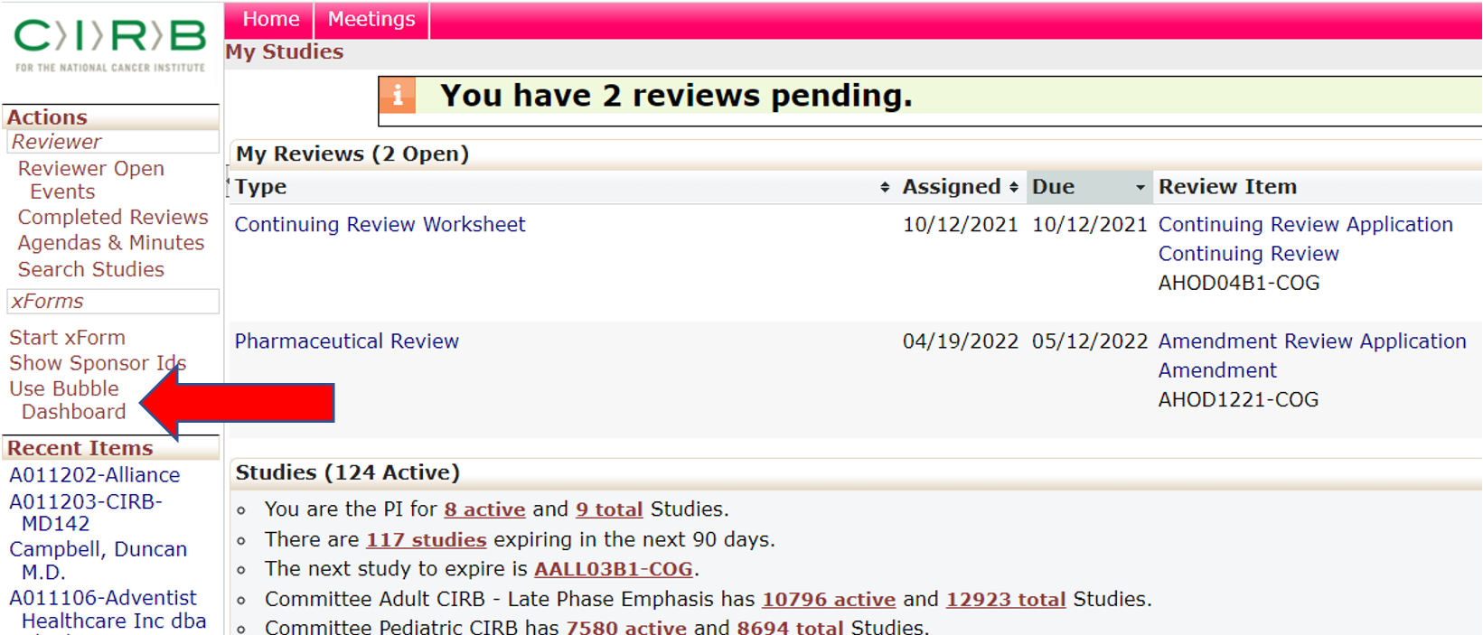

- Your dashboard will now change in appearance. Place your cursor on the CIRB tab(s) (red arrow) at the bottom of the screen and then drag it to the top navigation ribbon (blue arrow). NOTE: Only Boards to which are you assigned will appear in the user dashboard.

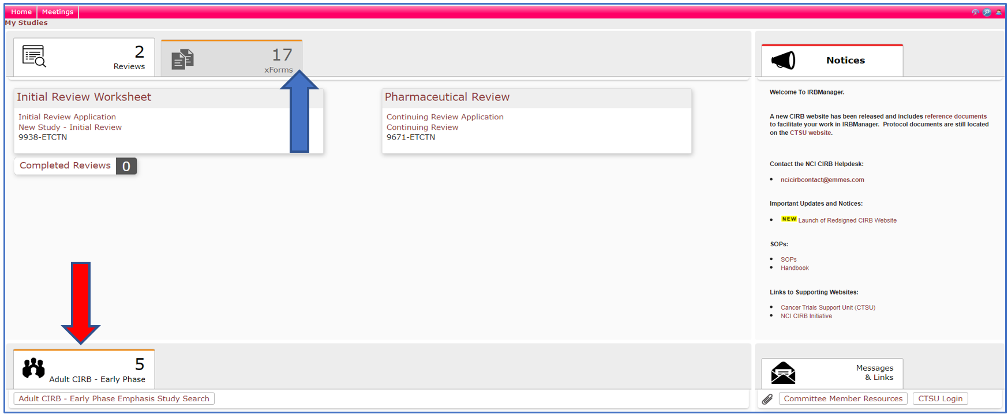
- The Board tab(s) should now be in the top navigation ribbon. In the view below, the Reviews tab if the first tab moving left to right. You may click on any of the tabs to rearrange their order in the navigation bar. To move a tab, click on the tab and drag it to the appropriate position.

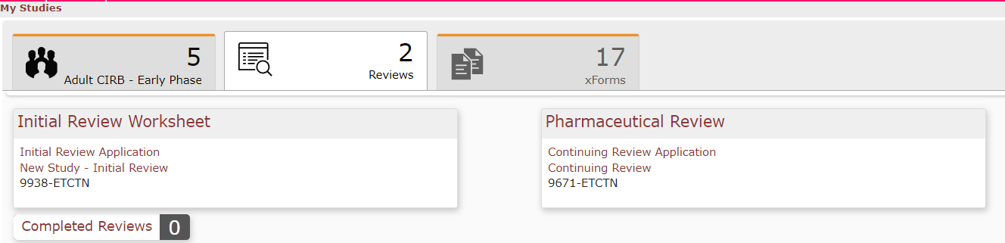
IRBManager User Dashboard Layout
- The user dashboard is divided into three main sections:
- The primary upper navigation bar (blue arrow)
- The secondary upper navigation bar (yellow arrow)
- The Notices right navigation bar (red arrow)
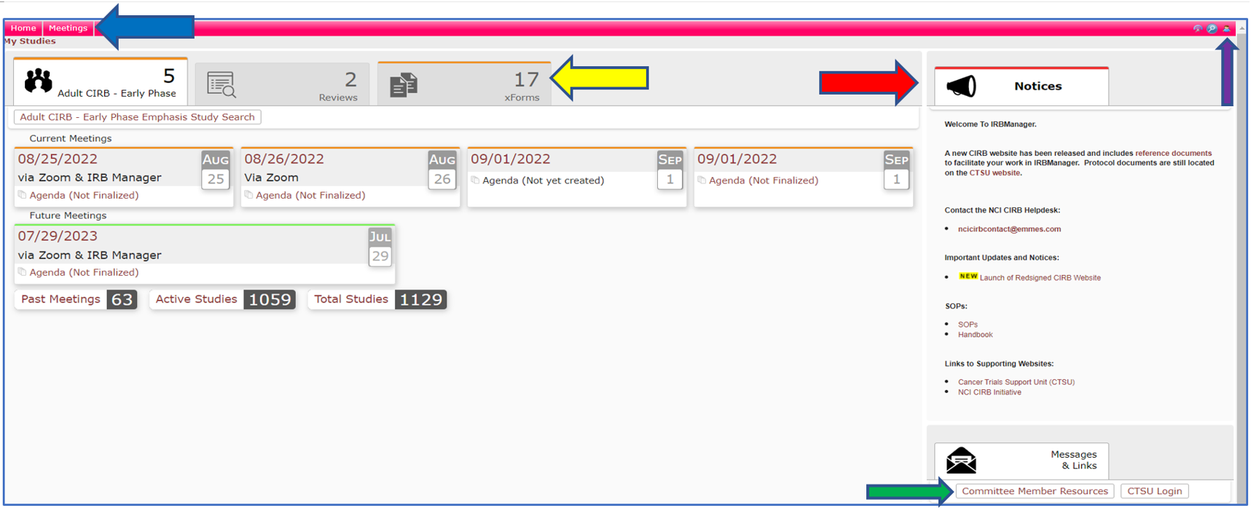
- The primary upper navigation bar contains two sets of links: Home and Meetings (blue arrow) and the Menu (purple arrow).
The Menu (purple arrow) contains user functions:
- The Sign off link will end the user session.
- The Use Power Dashboard reverts the user dashboard to the power setting.
- Dark Mode will reverse the white areas to black, thus producing less light from the interface.
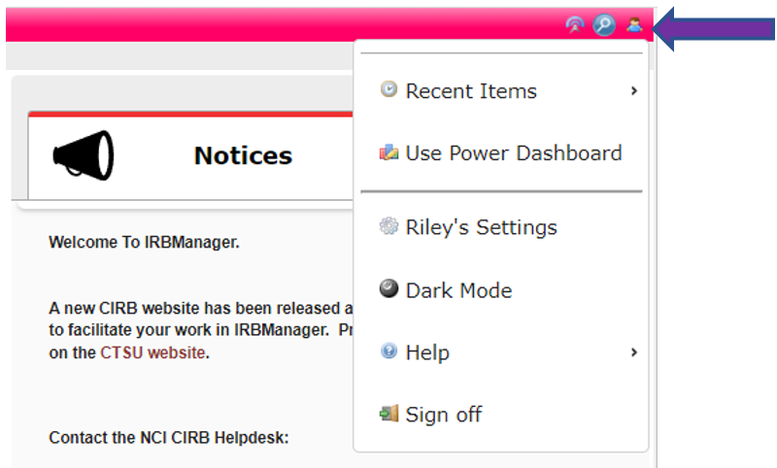

- The Home page contains the associated Board(s) (blue arrow), Reviews (yellow arrow), and xForms (red arrow) tabs. As a general rule, Committee members will almost exclusively use the Board and Reviews tabs.
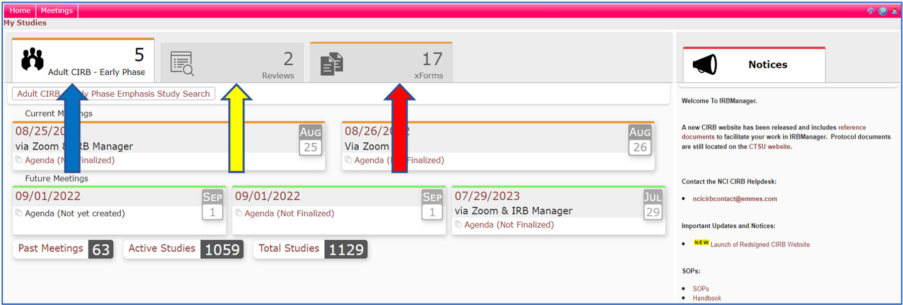
- The Board tab contains the list of all current meetings (blue arrow) and agendas (red arrow) associated with the identified Board. Members will only see Boards on which they have an association.

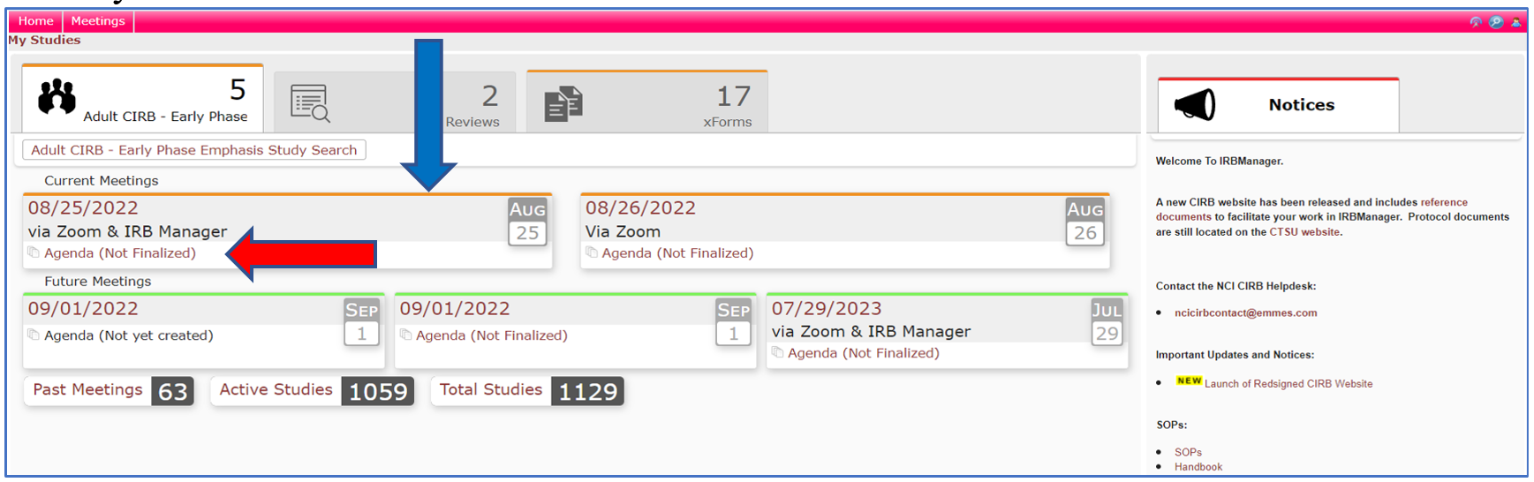

- The Reviews tab contains the list of all Reviewer Worksheets assigned to the Board Member for specific board meetings. Each Review contains a link to the Reviewer Worksheet (blue arrow), Application (yellow arrow), and the Study ID (red arrow).

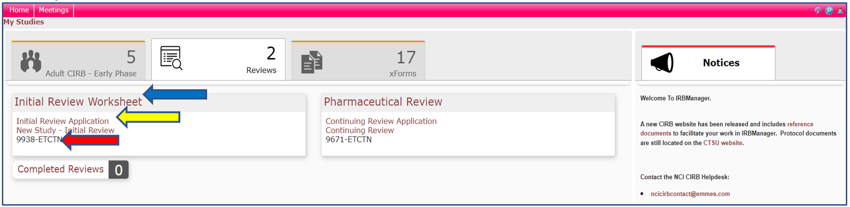

- The xForms tab contains the list of xForms (worksheets) associated with the “Awaiting Your Attention”, “Unsubmitted”, and “Submitted and In Process” tabs from all CIRB Signatory Institutions to which you are affiliated or have a role.
The corresponding worksheets will display upon selecting the appropriate sub tab. If you have no other Signatory Institution affiliations, the xForms tab will not appear. Most Board members will not see the xForms tab.
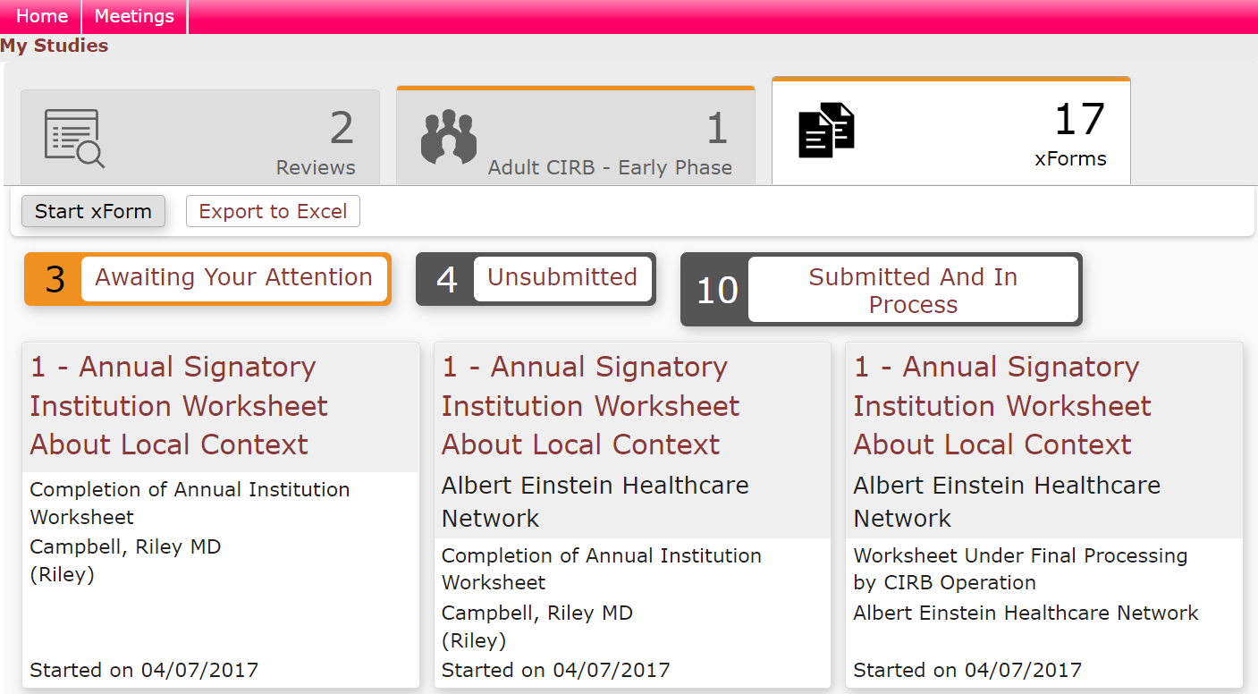
- To access the Meetings page, click on the Meetings link in the upper navigation bar.
The Meetings page is to divided into two sections:
  - the secondary upper navigation bar, which lists all the meetings by year (blue arrow), as well as the individual meetings link (yellow arrow)
  - the left navigation bar, which primarily contains the link to the “Committee Member Resources” page (red arrow)

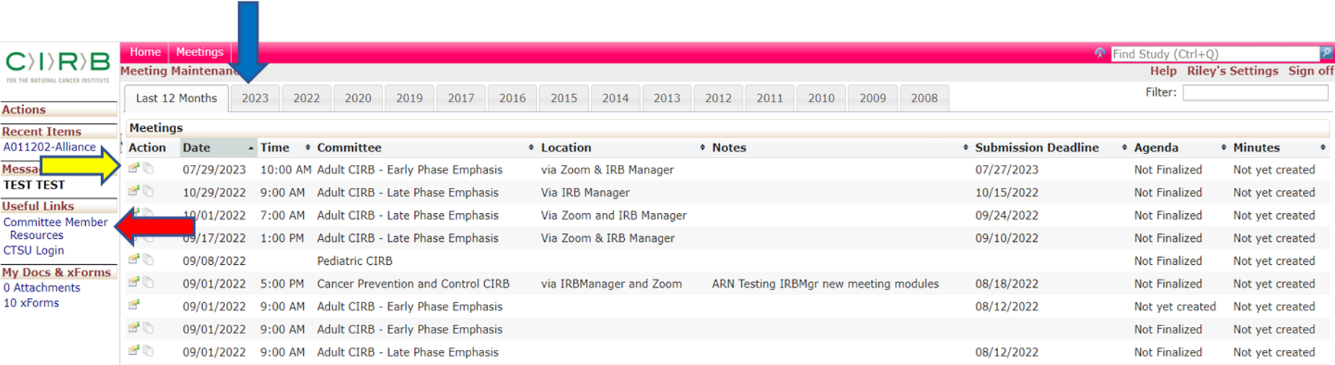

Viewing a Meeting Agenda
- From the Home page, click on the Board tab (blue arrow) to view the meeting Agenda you wish to see. This will display all current, uncompleted meetings.

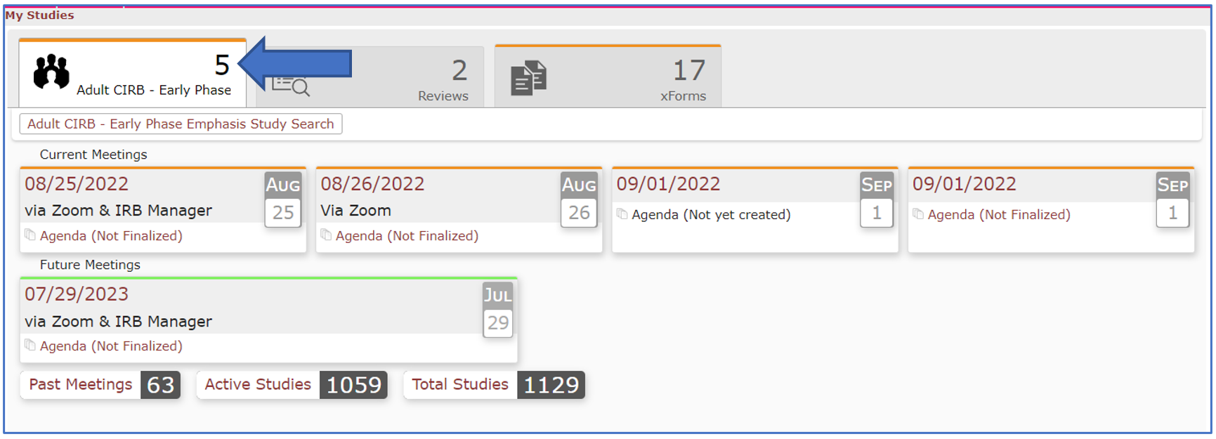

- Click on the “Agenda (Not Finalized)” (red arrow). This will open the agenda in a new tab in your browser.

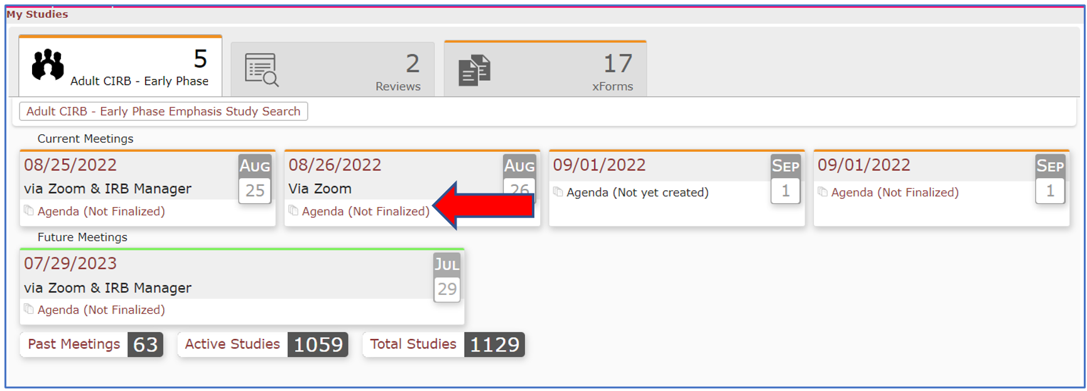

- The agenda closely matches the ePanel layout and contains the same sections, section information, and language.

- Scroll down to the section you wish to review. Active links will appear as an underlined blue text (red arrow).

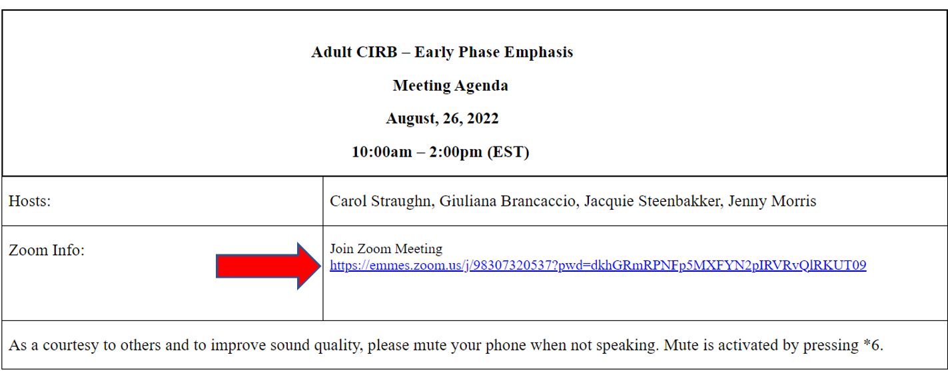
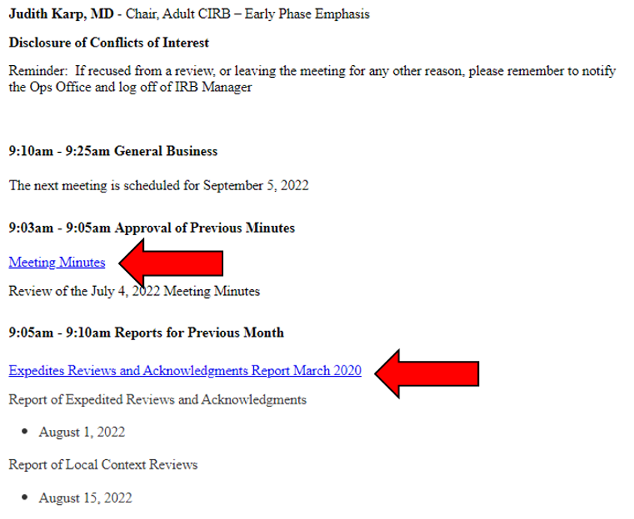

Viewing an Existing Reviewer Worksheet
- Review assignments can be found under each Full Board event.

- Assigned reviewers are listed at the top of the event (red arrow).

- Assigned Reviewer Worksheets are listed at the bottom of each event (blue arrow) and include the type of Reviewer Worksheet followed by the name of the assigned Board member. You can view any Reviewer Worksheet that has been started by clicking on the appropriate box. NOTE: Reviewer Worksheets that have not been started or don’t have saved changes will not appear and the interface will display only the Worksheet header information.
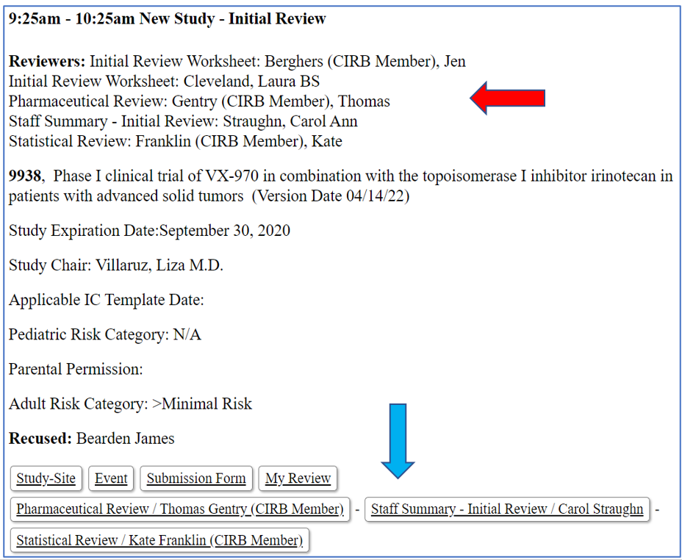

Viewing the Application for a Study Review
- To view the Application for a study event, click the “Submission Form” button (blue arrow) at the bottom of the review event.

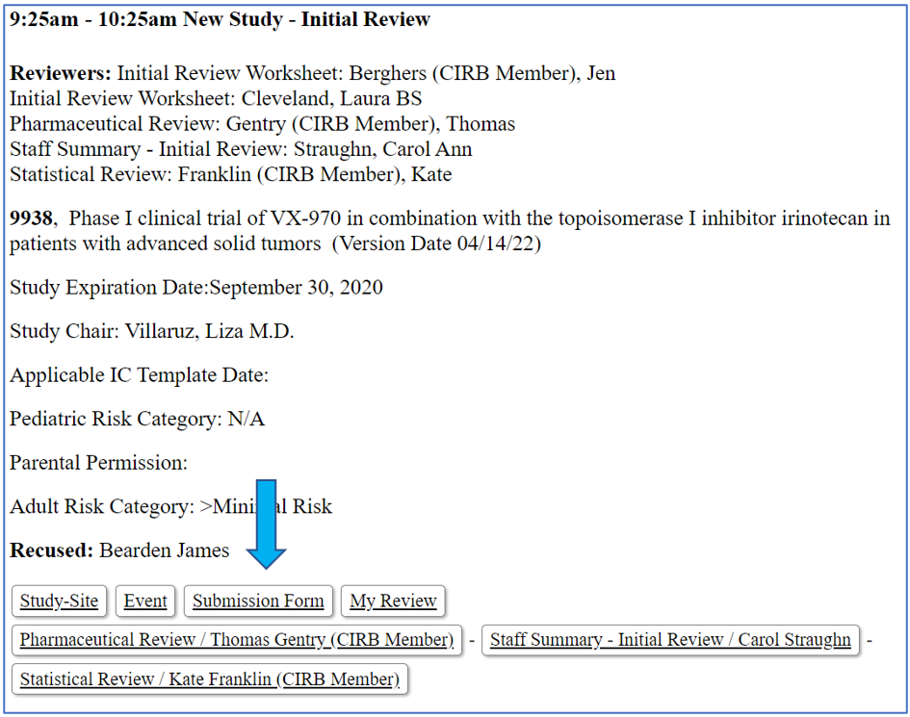

- The Application will appear in a new tab in your browser and will include three discrete stages: Start xForm stage, Application Submission stage, and CIRB Ops Review stage.

- The Application Submission stage contains information provided by the submitting Network Group. This is the stage on which you should focus your review.
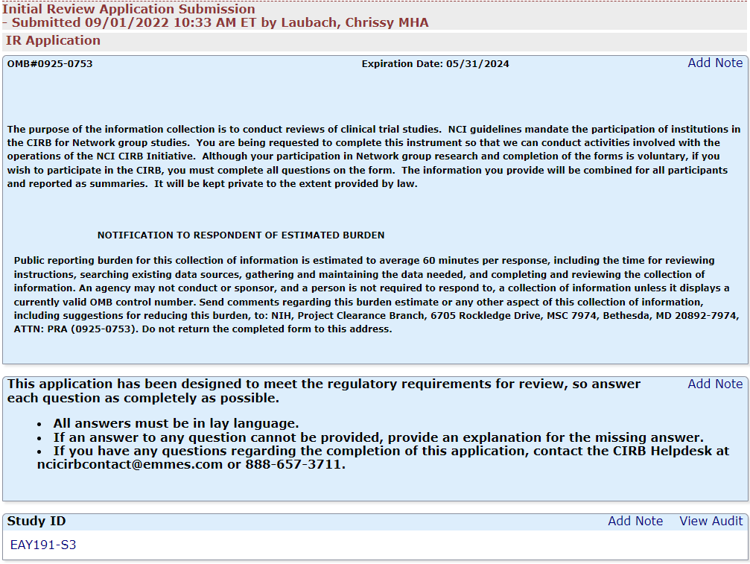

- All attachments are embedded in the Application. Click the link (red arrow) to open the attachment for review. The attachment will either open in a new tab or browser window or will open as an independent document link (i.e., as a Word, PDF, or Excel, etc.) at the bottom of the browser screen.

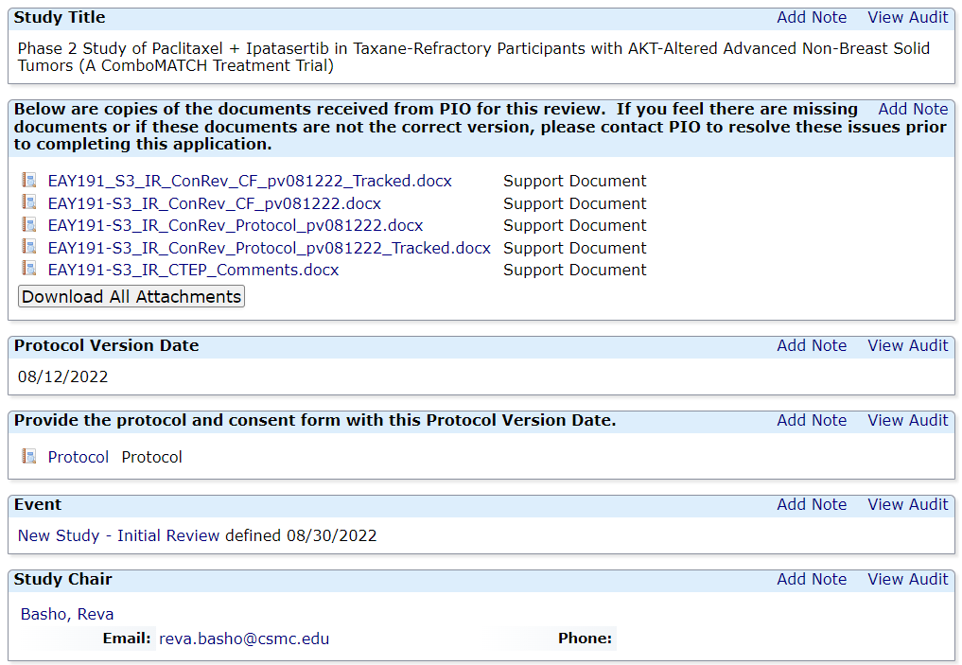
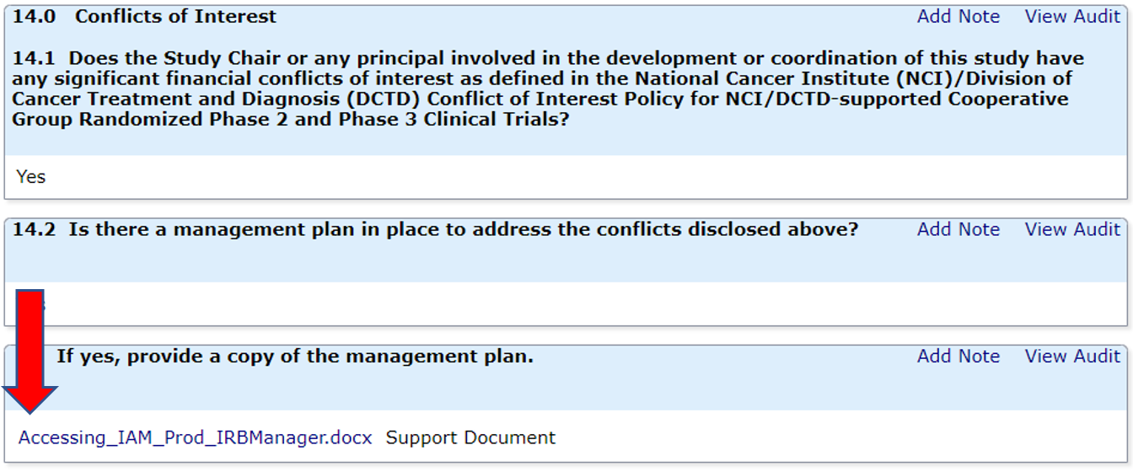

Starting an Assigned Reviewer Worksheet for a Study Review
There are three methods for accessing an assigned Reviewer Worksheet.
- Using the link provided in the study-specific email notification:
- Accessing the Reviewer Worksheet through the Review tabs on the user dashboard in IRBManager
- And lastly, accessing the Reviewer Worksheet through the specific study event on the meeting Agenda in IRBManager

Using the Email Notification
- All assigned reviewers will receive an email for each assigned review. The email lists the study event and a link to the Reviewer Worksheet. Clicking the Reviewer Worksheet link will take you to the IRBManager login page (if you aren’t already logged into IRBManager). Once you enter your IAM or ID.me login information, you will be taken to the Reviewer Worksheet. Refer to the Accessing IRBManager for more information on logging into IRBManager

Reviews Tab on User Dashboard

- You can also access any assigned Reviewer Worksheet through the Reviews tab (blue arrow) on the user dashboard.
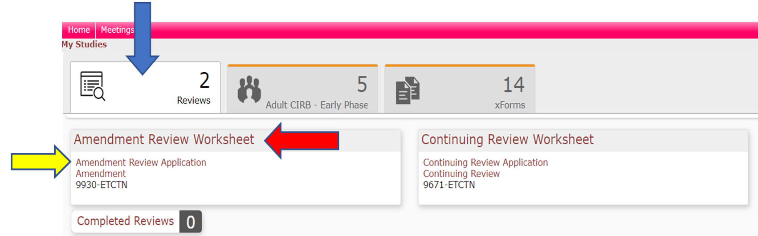

- Click the Review Worksheet link (red arrow) to open the Worksheet. The Worksheet will open in a new browser tab.

- Return to the Agenda tab and click the Application link (yellow arrow) to open the Application. The Application will open in a new browser tab.

Review Assignment on the Agenda
- You can also access any assigned Reviewer Worksheet through the Agenda under the Board tab on the user dashboard.

- Click on the Board tab (blue arrow) to view the meeting Agenda you wish to see. This will display all current, uncompleted meetings.

- Click on the “Agenda (Not Finalized)” (red arrow). This will open the agenda in a new tab in your browser.

- Refer to the Viewing a Meeting Agenda section for more information on accessing the agenda.

- Scroll through the Full Board study events in the agenda to the appropriate study with your name listed as an assigned reviewer. Reviewers are listed at the top of each study event (red arrow).

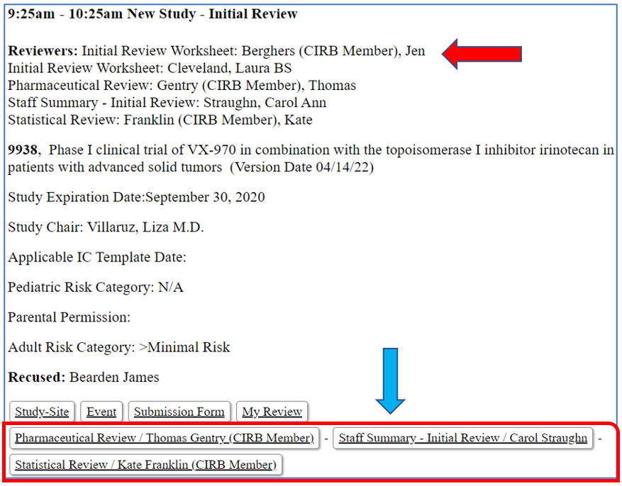

- Once the study event has been located, click on the button displaying the Reviewer Worksheet and your name (blue arrow).

- This will open the Reviewer Worksheet in a new browser tab.

- Open the Application by clicking on the Submission Form button (red arrow). Please refer the Viewing the Application for a Study Event section for more information.

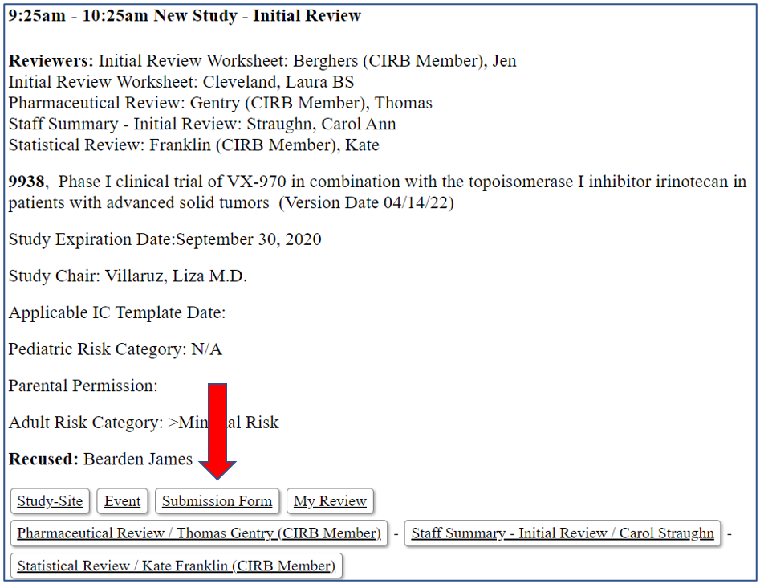

- You are now ready to review the application and complete the Reviewer Worksheet.

- You can save your work at any time by clicking the Save for Later button at the bottom of the Reviewer Worksheet screen.
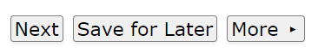
- Once you have completed your review and you are ready to submit it, click the Next button. This will take you to the confirmation page. You will have the option to:
  - Return to the worksheet by using the Go Back button;
  - Saving your work by using the Save for Later button;
  - Printing the worksheet as a PDF or to a printer using the Print button;
  - Submitting the worksheet to CIRB Operations staff by clicking the Submit button.

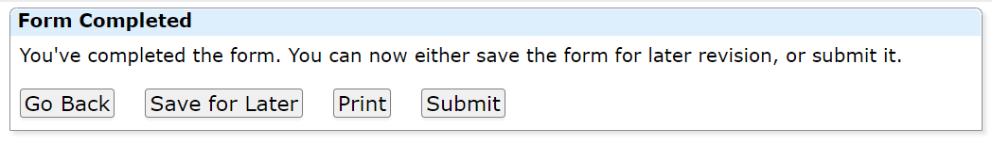
- Clicking the Submit button will generate the following message. You are now finished with this study review and may close the Worksheet window.

Starting an Unassigned Reviewer Worksheet for a Study Review
- Log into IRBManager and go to the Agenda under the Board tab on the user dashboard. Refer to the Accessing IRBManager and Viewing a Meeting Agenda sections for more information on accessing IRBManager and the agenda.

- Scroll through the Full Board study events in the agenda to the appropriate study.

- Once the study event has been located, click on the button displaying the My Review button (blue arrow) at the bottom of the event.

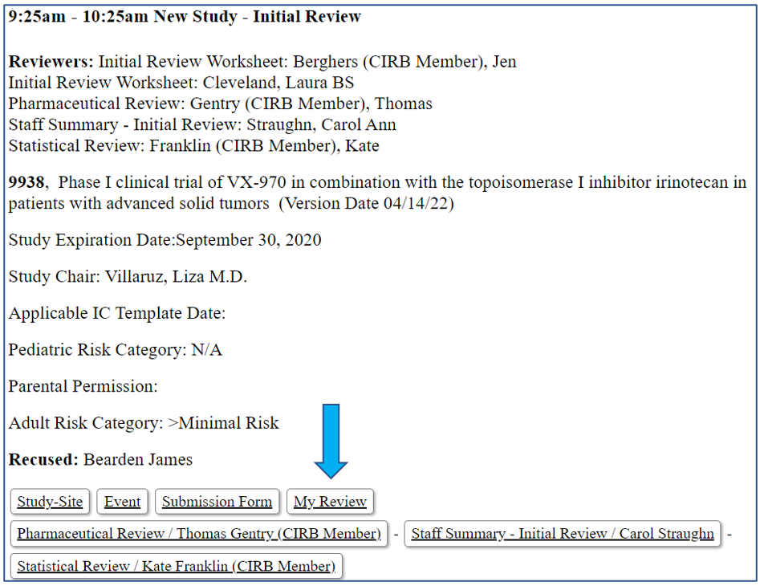

- This will open the Reviewer Worksheet in a new browser tab.

- Open the Application by clicking on the Submission Form button (red arrow). Please refer the Viewing the Application for a Study Event section for more information.

- You are now ready to review the application and complete the Reviewer Worksheet.

- If you would like to review the Reviewer Worksheet from another Board member, click on the appropriate button with the Review Worksheet and Board member name. Please refer to the Viewing an Existing Reviewer Worksheet section for more information.

- You can save your work at any time by clicking the Save for Later button at the bottom of the Reviewer Worksheet screen.

- Once you have completed your review and you are ready to submit it, click the Next button. This will take you to the confirmation page. You will have the option to:
  - Return to the worksheet by using the Go Back button;
  - Saving your work by using the Save for Later button;
  - Printing the worksheet as a PDF or to a printer using the Print button;
  - Submitting the worksheet to CIRB Operations staff by clicking the Submit button.

- Clicking the Submit button will generate the following message. You are now finished with this study review and may close the Worksheet window.

Navigating the Application

- To open the Application, click on the “Submission Form” button under the appropriate event on the Agenda or using the “Review Application” link under the Reviews tab. Please refer to the sections on Viewing a Meeting Agenda and Reviews Tab on User Dashboard for more information.

- The Application will appear in a new tab and will include three discrete stages: Start xForm stage, Application Submission stage, and CIRB Ops Review stage.

- The Application Submission stage contains the actual application completed by the submitting Network Group. This is the stage in which you should focus your review.

- All attachments are embedded in the Application. Click the link to open the attachment for review. The attachment will either open in a new tab or browser window or will open as an independent document (i.e., as a Word, PDF, or Excel, etc.).
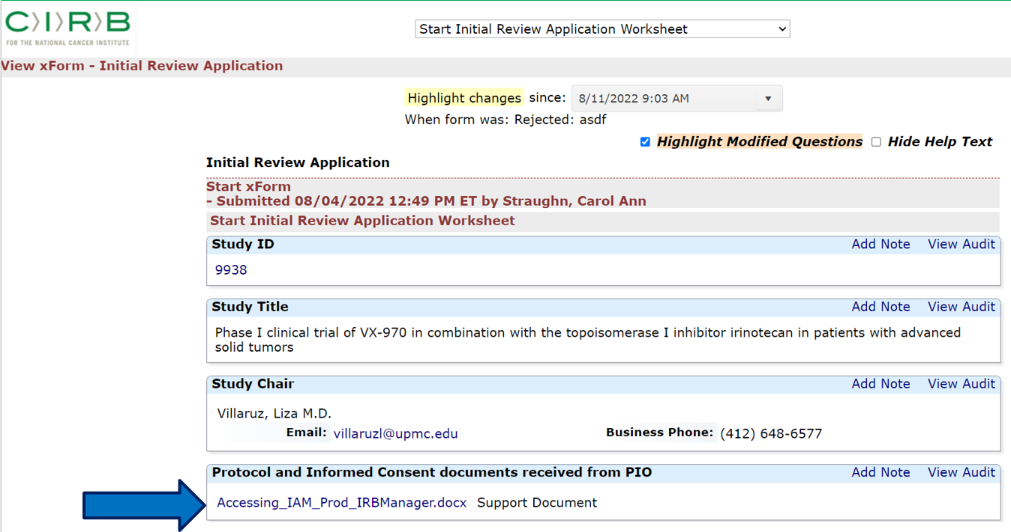

- At the bottom of the Application, there is the More button (blue arrow). Here you will find additional actions that you can used to assist in your review.

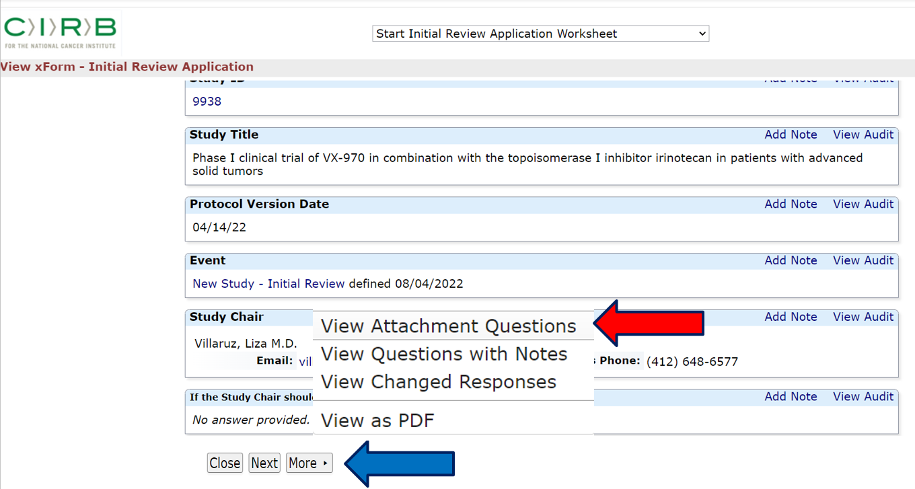
- Click the “View Attachment Questions” (red arrow) link to collapse the application to view only those questions that have attachments.

- Click the “View Questions with Notes” link to view those questions with notes. Notes usually created by the CIRB Coordinator and may or may not have corresponding responses submitted the Network Group staff member who completed the application.

- Click the “View Changed Responses” link to view those questions that were modified since the last submission.

- You may also click the “View as PDF” link to generate the application as a PDF, which you may then save to you local computer or print as a hard copy.

Viewing Archived Agendas
- Historic agendas are available under the Meetings tab (blue arrow) on the user dashboard in IRBManager. Refer to the Accessing IRBManager section for more information on accessing IRBManager.

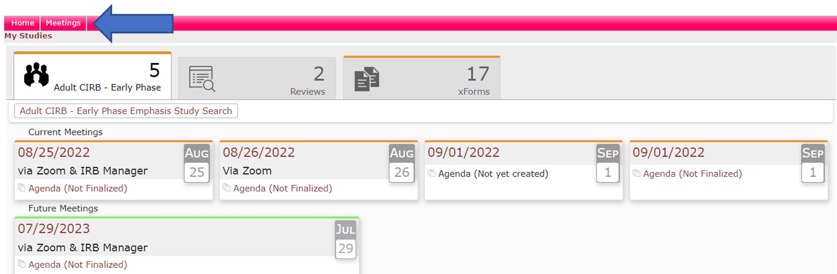

- Select the Year tab (blue arrow) for the agenda you want to view and then click on the Agenda icon (red arrow) to display the agenda. NOTE: Agendas created before September 15 will not include the associated Reviewer Worksheets. You will need to contact your CIRB Operations Board representative for individual Reviewer Worksheets from older meetings.

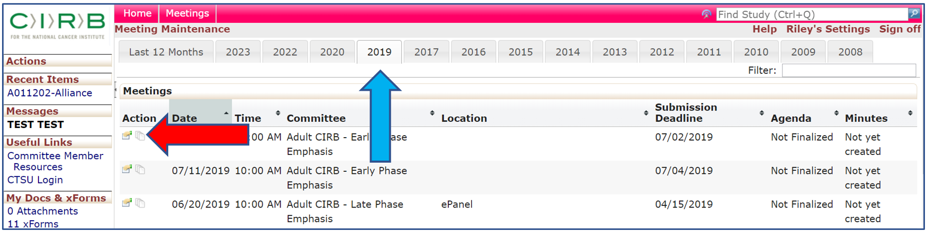

Viewing CIRB Resource Page
- The Member Resource Page (blue arrow) is located under the main Home page of the user dashboard. Refer to the Accessing IRBManager section for more information on accessing IRBManager.

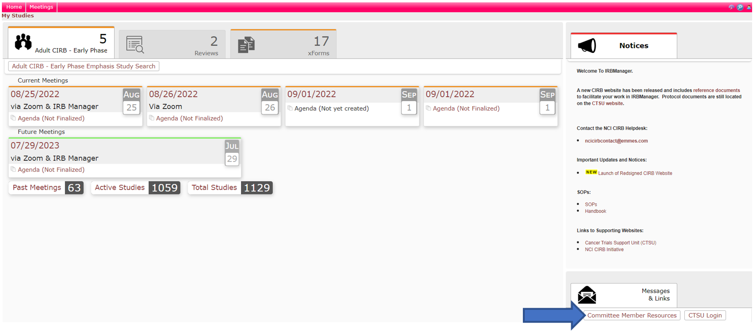

- This will open a new tab with important resources for Board members, including CIRB Policies, Education Day materials, Educational Topic, and various regulatory references and links.

